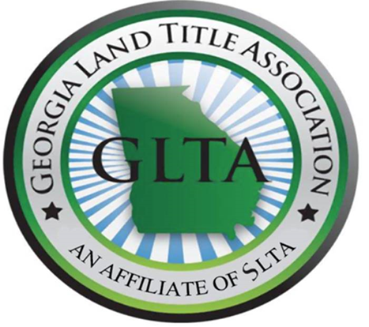

Georgia 2019 Spring Seminar
March 19, 2019

Cobb Galleria

7:30 Registration Opens

7:55-8:00 Welcome Remarks- Rhee McCallum, SLTA Georgia Education Chair

8:00-8:30 Closing Protection Letters
Rhee McCallum, Associate Underwriter
Chicago Title and Commonwealth Land Title Insurance Company

8:30-9:30 Documenting the Authority of Entities in Real Property Transactions
C. Elizabeth Jones, Esq.
Thompson O'Brien Kemp & Nasuti, P.C.

9:30-9:45 15 Minute Break

9:45-10:45 Ethics & Risk Management: Could Have, Should Have, Would Have
Jennifer M. Guerra, Esq., Partner
Carlock Copeland & Stair, LLP

10:45-11:45 Fraud and Financial Crime Threats
William A. Cromer, Special Agent
Federal Bureau of Investigation

11:45-12:45 Lunch

12:45-1:45 Probate Primer for the Real Estate Attorney
Shunta V. McBride, Esq.
The Law Office of Shunta V. McBride, LLC

1:45-2:15 2019 Georgia Legislative Update
Mark Robinson, Esq., Vice President and Georgia State Counsel
Old Republic National Title Insurance Company

2:15-2:30 15 Minute Break

2:30-3:30 Bankruptcy Basics for Dirt Lawyers
Kelsea Laun, Esq., Vice President and Regional Underwriting Counsel, Southeast
North American Title Insurance Company

