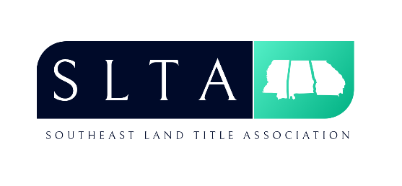
SLTA Mississippi Title School
May 20, 2019 - Beau Rivage Resort, Biloxi, MS

A G E N D A

7:30 am – 8:00 am Registration & Continental Breakfast
8:00 am – 9:00 am “E-Closings” by Courtney L. Robbins, Esq. of Luckett Land Title, Inc.
9:00 am – 10:00 am “Cyber Security and Fraud Prevention” by Heather D. Oliver of AVP Treasury Department
10:00 am – 10:15 am Break
10:15 am – 11:15 am “Ethics of Social Media” by Mike McKay of Watson Heidelberg, PLLC
11:15 am – 12:15 pm “Escrow Accounts” by Jennifer Jones of North American Title Insurance Company
12:15 pm – 1:15 pm Lunch
1:15 pm – 2:15 pm “Surveys/Encroachments” by Don Odgen of First American Title Insurance Company
2:15 pm – 3:15 pm “Legislative Update” by Warren Laird of Stewart Title Guaranty Insurance Company
3:15 pm – 3:30 pm Break
3:30 pm – 4:30 pm “Bankruptcy” or “Probate Matters” by Brad Jones of Old Republic National Title Insurance Company
4:30 pm Adjourn

Continuing Education Credits: 7.0 CLE Credits, including 1.0 Ethics

