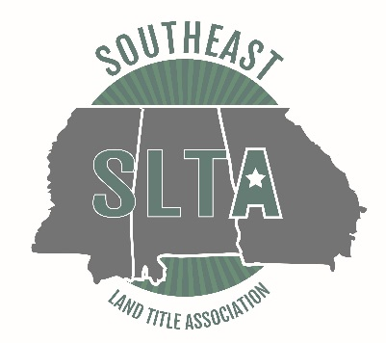
2018 SLTA Mid-Year Meeting
April 16, 2018
Renaissance Birmingham Ross Bridge Resort
4000 Grand Ave., Birmingham, AL

Schedule at a Glance
Sunday, April 15, 2018
2:00 pm – 3:00 pm Committee Meetings
3:00 pm – 4:30 pm Board of Directors Meeting

Monday, April 16, 2018
8:00 am – 8:30 am Registration
8:15 am – 8:30 am Welcome and Announcements
8:30 am – 9:30 am “Multi-State Legislation Update (Governmental Affairs Panel) by Wes Long, Chair of Alabama Governmental Affairs Committee;
Deborah Bailey, Chair of Georgia Governmental Affairs Committee;
and Terry Weill, Chair of Mississippi Governmental Affairs
Committee
9:30 am – 10:30 am “Underwriter Panel (AL/MS/GA)” – by Danny Crotwell of Stewart Title Guaranty Company; Gina Matthews of Old Republic National Title Insurance Company; Donna Snider of First American Title Insurance Company; Warren Laird of Stewart Title Guaranty Company; Rhee McCallum of Chicago Title Insurance Company
10:30 am – 10:45 am Break with Exhibitors
10:45 am – 11:45 am “Economic Update” by K. C. Conway of the Alabama Center for Real
Estate (ACRE)
11:45 am – 12:45 pm Lunch
12:45 pm -1:45 pm “Ethical Obligations of Title Agents and Attorneys for Cyber
Security” by Brad Jones of Old Republic National Title Insurance
Company
1:45 pm – 2:00 pm Break with Exhibitors
2:00 pm – 3:00 pm “E-notarizations – Current Status” by Danielle Kaiser of North
American Title Insurance Company
3:00 pm – 4:00 pm “Understanding the 2016 ALTA Forms” by Joe Powell of Fidelity
National Title Group

