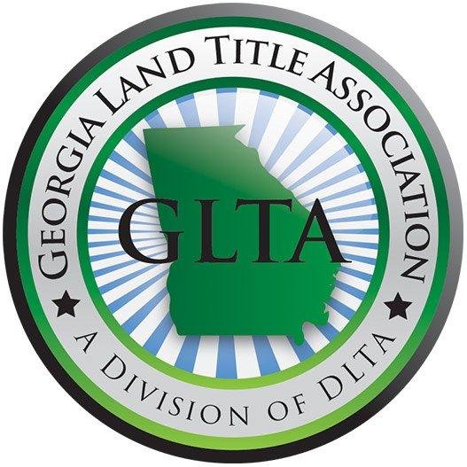

FALL 2014 AGENDA

October 9, 2014

8:15 Registration Opens

8:50 Welcome Remarks: Amanda Calloway, Esq.
Education Committee Chairperson

9:00-10:00 Unique Issues that Arise in Busted Subdivisions
Chad Henderson, Esq.
Henderson Legal LLC

10:00-11:00 CFPB and ALTA Best Practices
Monica K. Gilroy, Esq.
Dickenson Gilroy LLC

11:00 15 Minute Break

11:15-12:30 Ethical Considerations from Courthouse to Commitment
Kyle J. Levstek, Esq.
Calloway Title and Escrow, LLC

12:30 Lunch

1:30-2:45 Private Covenants Encumbering Real Property and their Effect on Title Insurance
Leonard R. Gray, Jr., Esq.
First American Title Insurance Company
and
Warren O. Wheeler, Esq.
Schreeder, Wheeler & Flint, LLP

2:45 15 Minute Break

3:00-3:30 Georgia Advisory Opinion on Witness Only Closings
Carol V. Clark, Esq.
Carol V. Clark Law

3:30-4:30 Current Legislation on Real Estate Matters Being Worked on in the Georgia General Assembly
Mo Thrash
Governmental Affairs Director, McCalla Raymer, LLC

